**Chapter 1: INTRODUCTION**

**Topic – 1: Language Processors**

**Introduction**

* **Source language:** Language which is **read first** by the compiler.
* **Target language: Final language** the source language is converted into.
* Interpreters **directly** produce outputs without any **intermediate target program**.
* **Machine language** produced by **target program** in **compilers** are faster than **interpreters** in mapping inputs to outputs.
* **Java** combines **compilation** & **interpretation** as shown below.

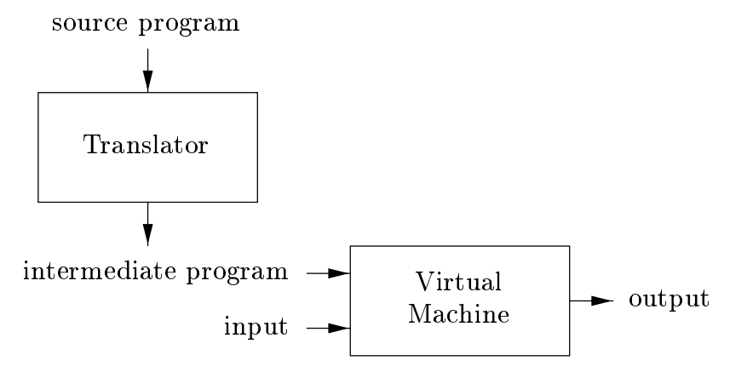

* **Java** source programs are compiled into **intermediate form** called **bytecode**.
* **Bytecode** is then interpreted by **virtual machine**.
* **Bytecodes** compiled on one machine can be **interpreted** in another.
* **Just-in-time** compilation fastens Java program execution by compiling **bytecodes** further to **machine language** during **compilation** itself.

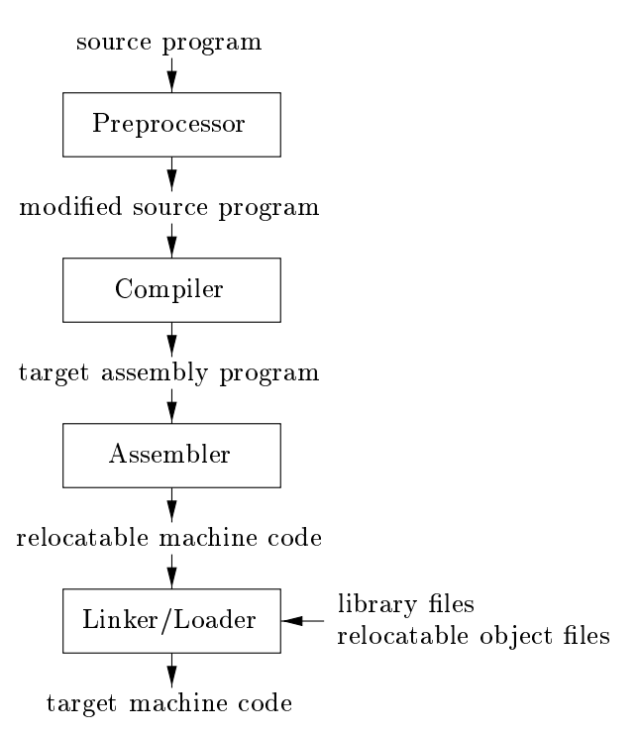

* **Preprocessor:** Collects the source program.
* **Macros:** Short programs
* Compiler often converts **modified source program** to assembly program, as their output is easier to debug.
* Programs if compiled in **pieces** by compiler, their machine codes are linked using **linker** along with relevant **objects** & **library files**.
* Linker resolves **clashing memory addresses issue** among the compiled file, like one file pointing to location pointed by another file.
* **Loader:** Reserves memory space for **executable object files** for execution.

**Note!**

**🡪 HLL stands for high-level language.**

**🡪 Similarly, LLL means low-level language.**

**🡪 A compiler that translates a HLL into another HLL is known as source-to-source translator.**

**Topic – 2: Structure Of Compiler**

**Analysis**

* **Source program** to **target program** mapping involves ***analysis*** & ***synthesis***.
* Analysis stage creates an **intermediate program** using the pre-defined grammatical structure.
* Analysis is also known as **front end** of the compiler.
* It also checks if **source program** is syntactically & semantically **correct** or **not**.
* If **not**, provides **appropriate message** to user for correcting it.
* Also, it stores **information** from **source program** in form of **symbol table**.
* These information are then passed to **synthesis** part.
* Basically, **analysis** is all about **checking the syntax** & storing necessary data before passing data for **target program**.

**Synthesis**

* Also known as **back end** of the compiler.
* It converts the **intermediate program** & information in **symbol table** into target program.

**Phases In Compiler**

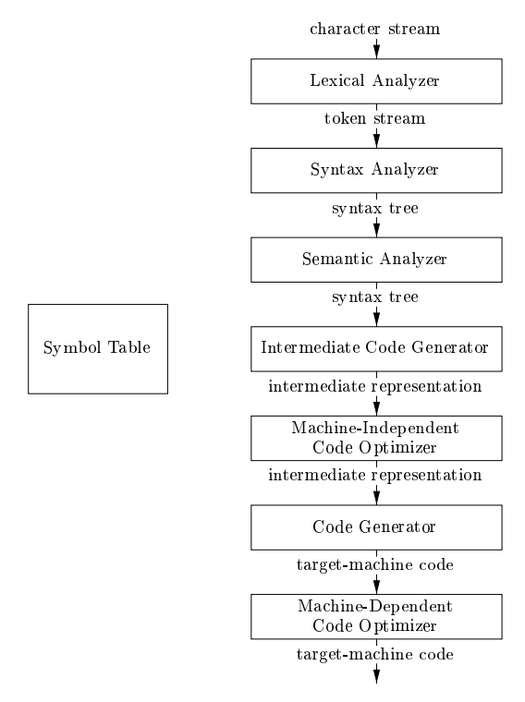

* It’s a more **descriptive** representation of phases.
* In real, **multiple phases** may be grouped under **one phase**.
* And the phases among the groups might **not** be explicitly made, they might exist **by default**.
* For example, if **C** is used for making a **compiler**, then it **by default** covers some of the phases in the diagram.
* The ***machine-independent optimization*** stage is optional.

**Topic – 3: Phases Of Compiler**

**Lexical Analysis**

* **1st** **phase** of compiler.
* Also known as ***scanning***.
* **Lexical analyser** reads & groups the characters in **source program** into meaningful sequences.
* These sequences are known as ***lexemes***.
* A token is generated for each **lexeme** in following form.

**<token_name, attribute_value>**